Tours/ Visits of Physics Department (2021-2022)
- NIGHT SKY WATCH (15-11-2021)
The Chandrayaan Vipnet Club of Physics department, Hans Raj MahilaMahaVidyalaya, Jalandhar organized “Night Sky Watch” on 15th November, 2021 from 5:00 PM to 8:30 PM at IT Conference ground. Total 127 students of various streams of the college participated in this life time experienced event. HOD PG deptt. of Physics Mrs. Saloni Sharma and faculty members welcomed the Resource Persons, Mr. Akashdeep Singh (Incharge of Night Sky Watch) and his technical assistant Mr. Manpreet Singh from Pushpa Gujral Science city with a planter.
The HOD of physics department Ms. Saloni Sharma explained the students about Chandrayaan Vipnet Club and its activities. The event commenced with the fascinating videos, demonstrating the journey of two space probes named “Voyager1” and “Voyager 2” launched by NASA as a voyager program to study the outer solar system and interstellar space beyond the Sun’s heliosphere. “Voyager2” was launched on 20 August 1977, whereas, Voyager 1 was launched on 5 September 1977. After watching the videos, students seem eager to explore more about the universe.
In order to satisfy the curiosity of students Mrs. Saloni Sharma gave a power point presentation on “Universe and Celestial Bodies” to make them aware about the composition of our Solar System. She explained the Big Bang theory and creation of all the planets as well as their moons in a very remarkable manner. She told the students that Sun is about 149 million km away from Earth and the diameter of Sun is 109 times the diameter of Earth. Size of the other planets was also compared with that of the Sun. Basically her talk pivots around the moon (natural satellite of earth), Venus (third planet), Jupiter (fifth planet) and Saturn (sixth planet). Venus has the densest atmosphere consisting of 96% carbon dioxide. So, even though Mercury is closest to sun, Venus has the hottest surface of any planet in the solar system, with a temperature of 737 k. It is also known as the morning star and evening star. Jupiter is gas giant and is the first largest planet, mainly made up of hydrogen and helium. Being the second largest planet, Saturn is also a gas giant with an average radius of about nine and half times that of Earth. It only has one-eighth the average density of Earth; with its larger volume, Saturn is over 95 times more massive. She has also added the discussion of different phases of moon. To explore the awareness among the students regarding space research a small quiz was also conducted.
After the discussion, students couldn’t contain the excitement to see surface of moon and the three planets together. Mr. Akashdeep Singh and his assistant set the high power telescope in the college lawn to focus on moon, Venus, Uranus and Saturn. Faculty members of the college and students viewed the beautiful craters on the surface of moon, crescent phase of planet Venus, Jupiter with its five moons and the Saturn with beautiful rings. Students explored moon and planets patiently and everybody was seemed to be fascinated to see this magnificent spectacle. On this event, physics faculty, Mr. Sushil, Dr. Simmi Garg, Ms. Nidhi Pathak and Ms. Vidhi were also present.
Principal Prof. Dr.(Mrs.) Ajay Sareen applauded the Physics department for organizing such an innovative event.
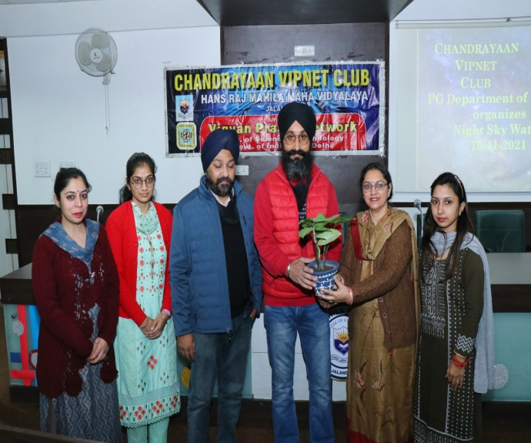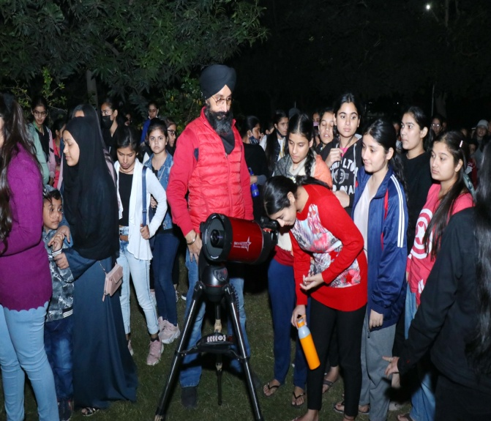
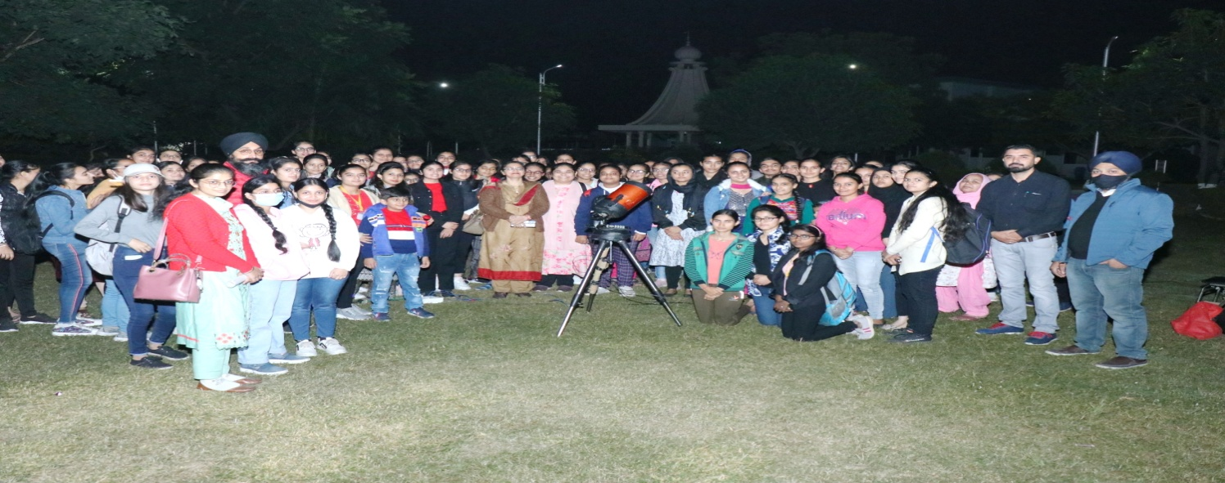
2. Report of One Day Educational Visit to National Institute of Renewable Energy, Kapurthala on 29th April 2022

Chandrayaan Vipnet Club of PG Department of Physics organized a one day educational visit. A team of 48 students accompanied by two teachers Mrs. Saloni Sharma and Mr. Sushil Kumar to Sardar Swaran Singh National Institute of Renewable Energy (SSS-NIRE), Kapurthala (Punjab) on 29th April, 2022. Spread over a sprawling campus of about 75 acres, the carries out and facilitates research, design, development, testing, standardization & technology demonstration eventually leading to commercialization of RD&D bio fuel. Students visited four research laboratories operational on synthesis, characterization and testing of biofuels Bioenergy and synthetic fuels in solid, liquid and gaseous forms for transportation, portable and stationary applications as well asDevelopment of hybrid/integrated energy systems based on solar energy and wind energy. They learnt about the various processes for production of Bio-fuel in chemical conversion R&D Lab and Bio-Chemical conversion of R&D Lab, Designing,testing experimental efficiency of different models of Cook Stoves developed at NIRE and improving biomass Cookstove.In the hybrid/integrated energy systems labs, students learnt about working of solar panels for conversion of solar energy to electricity and various control factors for improving the output of solar panels. They also learnt about the application of Solar Panels for heating water in Solar Water heaters/Geysers. Students also saw the working model of Wind Mill, learnt about finding the threshold speed of wind required for converting wind energy to electricity.The students also interacted with Post Doc researchers as well as Research Scientist, to learn from their experience. Some students also enquired about the various study paths to get into such research institutes.The visit was very informative and students were motivated to undertake research as a career and utilize their knowledge for betterment of Society. After the educational visit the students also visited Gurudwara Baba Ber Sahib at Sultanpur Lodhi . Principal Dr. ( Mrs.) Ajay Sareen motivated the students to participate in more such visits to have practical experience and exposure with such research labs. She also congratulated the Faculty of the department on successfully organizing the trip.
